Pokhara University

Level: Bachelor | Semester – Spring | Year : 2008
Programme: BE |  | Full Marks: 100
Course: Electrical Engineering Materials |  | Time : 3hrs.

Candidates are required to give their answers in their own words as far as practicable.
The figures in the margin indicate full marks.

Attempt all the questions.

 | - Write down the physical significance of wave function ψ. Derive the Schrodingers' time independent wave equitation.  - If longest wavelength required photoelectric effect for a certain metal is 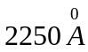.  Find  - Work function of the metal  - The velocity of electrons ejected from the metal surface if the same metal is radiated with 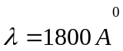.  - Kinetic energy of ejected electrons. | 8  7
 | - Show that the conductivity of electrons within metallic conductor is product of charge density and mobility.  - Explain in brief about electrical conduction in gases and arc discharge.  - The resistivity of copper at 20⁰C is 0.69 × 10⁻⁸Ωm and density of free electron, n = 8.5 × 10²⁸ m⁻³. Calculate the mean free time of electron in copper lattice.  (Given 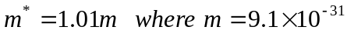 Kg) | 5  5  5
 | - Derive an expression for the junction width of a P-N junction diode.  - A Si wafer doped uniformly with 10¹⁷ Indium atoms per cm³ is further doped with 2.1 × 10¹⁸ Antimony atoms per cm³. Determine the position of Fermi energy with respect to the Fermi energy E_{Fi} in intrinsic Si. Given n_{i} = 1.45 × 10¹⁰ per cm³ at room temperature. | 8  7
 | - Define Polarization. Show that "there will be no polarization if 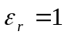".  - A parallel palate capacitor has an area of 20 cm² and a separation of 0.5mm. The space between the plates is filled with polyethylene. An alternative voltage with amplitude of 12V is applied at a frequency of 1.5 MHz. At this frequency, the real part of the relative permittivity is 2.25 and the loss tangent is 4 × 10⁻⁴. Calculate the energy dissipated per second. | 8  7
 | - Based on magnetization vector, explain the diamagnetism, ferromagnetism and ferrimagnetisms.  - Show that the diode equation for a P-N junction is 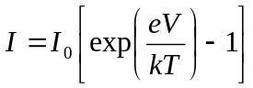, where I₀ is the reverse saturation current and V is the applied voltage. | 8  7
 | - Explain the floating zone method for crystal growing.  - A pn junction diode has a concentration of 10¹⁶ acceptor atoms cm⁻³ on the p-side and a concentration of 10¹⁷ donor atoms cm⁻³ on the n-side. What will be the built-in potential of the semiconductor materials of silicon? Also calculate the Junction width on p side and in n side. Take ,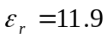. | 8  7
 | Write short notes on (Any Two):  - Hard and Soft magnetic material  - Conduction in liquids  - Effective Mass of Electron in Crystal | 2×5

